2020

# What is my application?

19COB155 Application Proposal

Fitnesse

(s) Anmol Naresh Dadlani B830342

The key purpose of the application I envisage is to motivate and enable me to achieve increased fitness levels.

Originally, I planned on making an application that would incorporate exercising with instant messaging, however, due to the Chat SDK that I wanted to use being very limiting in implementing my own specific features, I had to modify my idea.

I wish to continue with the fitness theme but other than using the instant messaging side, I want to implement analysis of activities added by the user. The reasoning behind this proposal is to show the user what activities they perform regularly, and which ones require the most effort.

In addition, applications developed for android devices are not usually optimized and built as well as their iOS counterparts. I have understood the main reason behind this could be that Apple has a small lineup of phones with similar screen ratios and those models are very popular; thus, application developers feel that there is a trade-off present where there is more gain with Apple smartphones.

My next thought was to integrate those two ideas together to form the application I am going to produce. I have decided to call it Fitnesse.

# APIs/SDKs

For use of graphs to show information regarding the user’s activities, I found a Chart library named, Hello Charts. For more information visit: <https://github.com/lecho/hellocharts-android>

To use Google Maps API, I require the Google Play Services SDK to be added to the android application, alongside the Google Maps API. For more information visit: <https://developers.google.com/maps/documentation/android-sdk/intro>

Firebase SDKs are also required to be added to be able to use the database within the application. For more information visit: <https://firebase.google.com/docs/android/setup#console>

# Requirements Specification

|  |  |  |
| --- | --- | --- |
| ID | Description | Rationale |
| 1 | Login page stores information of users on Firebase | Firebase contains an authentication table that keeps all passwords encrypted and any device can login to the app |
| 2 | Has atleast two distinct screens | To navigate through the app |
| 3 | Will require permissions | Requires Location permissions for tracking of where the activity was added – more permissions will be used. Location is just an example |
| 4 | Use intent to carry data throughout the app | To be able to use information regarding the user in all sections of the app such as the activity details |
| 5 | Be able to analyse activities | Be able to see user’s most performed workouts |
| 6 | Add sporting activities | To be able to track how much activity has been completed. |
| 7 | See minutes of activity performed over the month | To be able to check progress over the month and see any days where no exercise was completed. |
| 8 | Send notifications | To notify the user if no exercise has been completed. |
| 9 | Use Firebase as a database | Contains real-time databases and can natively activate push notifications through the console. |
| 10 | Must have a user guide | To show user how to use the application |
| 11 | User guide must be made using web technologies | So, guide can be accessed from anywhere not just the device |
| 12 | User must be able to see visual feedback when seeing the specific activity | To quickly be able to check if they spent less effort on a specific activity, to motivate the user to work harder next time. |
| 13 | User will be able to add description to every single activity | They can track what they did last time. This will only be visible to the user not their contacts when comparing activities |
| 14 | Wake up phone when notification received (use AlarmManager) | To show user that a new notification has been received |
| 15 | Be able to change profile picture | To be able to distinguish between different users in the homepage |
| 16 | App should allow user to observe trends in exercising | Users will be able to see previous months’ activities and can use the graph to visually compare if they have improved. |

# Explanation of Wireframes

(1) – This is the login page and it uses firebase for the login information

(2) – Homepage where you can either add activities, access your profile or see your activity analysis.

(3) – You can see an analysis of the activities you have done, it will be ordered by the number of times you have completed each activity in descending order.

(4) – Add an activity that the user has performed on the day with a description so the user can refer to it later. They cannot change the date or the location.

(5) – Viewing the activity so you can see more information on it like the location and the description of what the user did.

(6) – View profile and change notification settings.

(7) – Register a new user.

# Flowchart

How the application will work:

Register a new user (7)

Press Register button

Login Page (1)

Press logout button

Press Login and authentication cleared

Homepage (2) (2)

Click on Activity from list

Click ‘+’ icon

Click on List icon

Click on profile button

Add activity (4)

View Activity details (5)

See list of all categories user has played (3)

Profile (6)

Click on information logo

Change Notifications and Name

User guide - HTML

# Wireframes

1. (2) (3) (4) (5) (6)

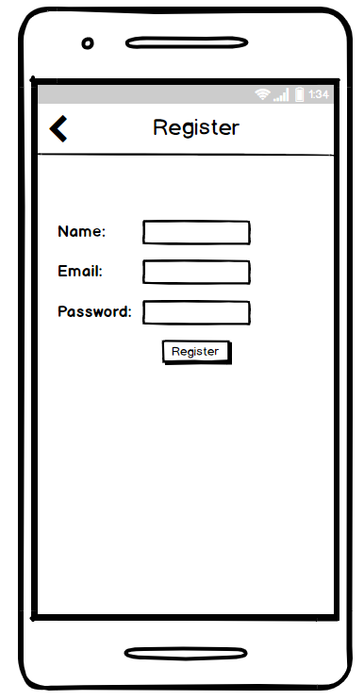

(7)